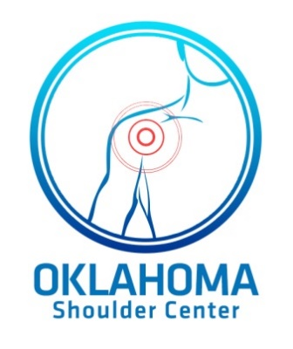

Oklahoma Shoulder Center PLLC

Betsy M. Nolan MD

725 NW 11th St

Oklahoma City, OK 73103

Ph: 405-278-8006

www.okshoulder.com

**Post-Operative Physical Therapy**

**Distal Biceps Repair**

**Post-Op**

* Splint at 90 degrees in supination for 2-3 weeks
* Sleep with brace locked to prevent inadvertent active flexion
* Splint/Brace

1. Partial repair: d/c at 3 weeks
2. Complete Repair: d/c at 6 weeks

* Note angle where tension on repair – Flex 40 degrees above this, then start supination/pronation here immediately post-op
* Begin active extension, passive flexion by 2-3 weeks. Limit extension to point where tension on repair noted intra-operatively.
* For motion: rest arm on table, with forearm hanging over edge. Can then actively extend. Flexion done passively.
* Sleep with brace locked to prevent inadvertent active flexion
* Splint/Brace

1. Partial repair: d/c at 3 weeks
2. Complete repair: d/c at 6 weeks

* Full extension at 6 weeks.
* No active flexion until 6 weeks.
* No strengthening until 12 weeks.
* Return to vigorous labor at 6 months.
* Continue to strengthen for 1 year.